Establish a new directory, populate it with script files, initiate an empty repository on GitHub, convert the local directory into a Git repository, and link it to GitHub for pushing the code into the repository.Perform merge, rebase, stash commands in following github repo.

Created NEW Repositiry

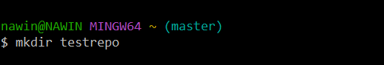

Created the file in the New Directory



Created the empty repo in GitHub
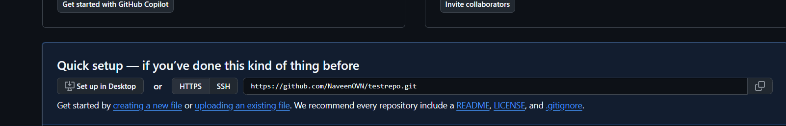

converting the local directory into a Git repository

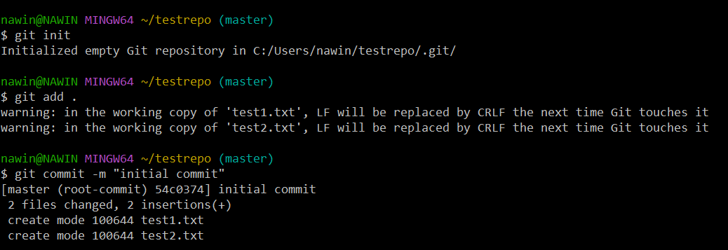

Linking Local Repo and Remote Repo

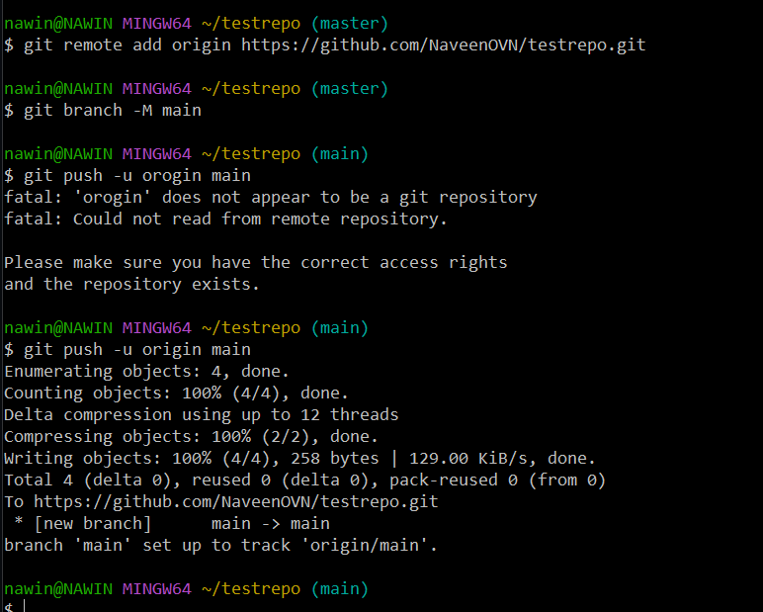

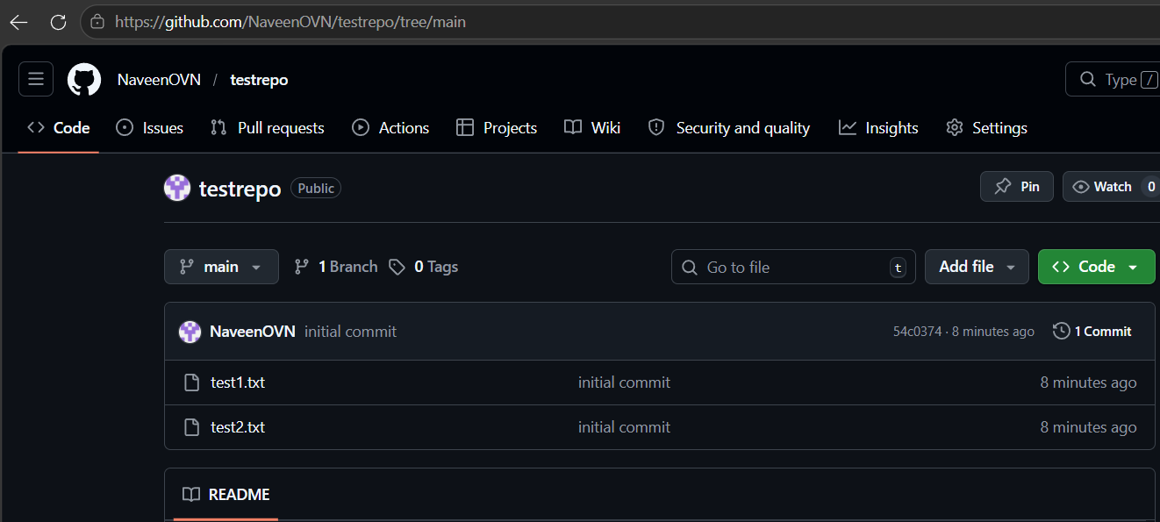

MERGE between Main & Feature Branch without conflict
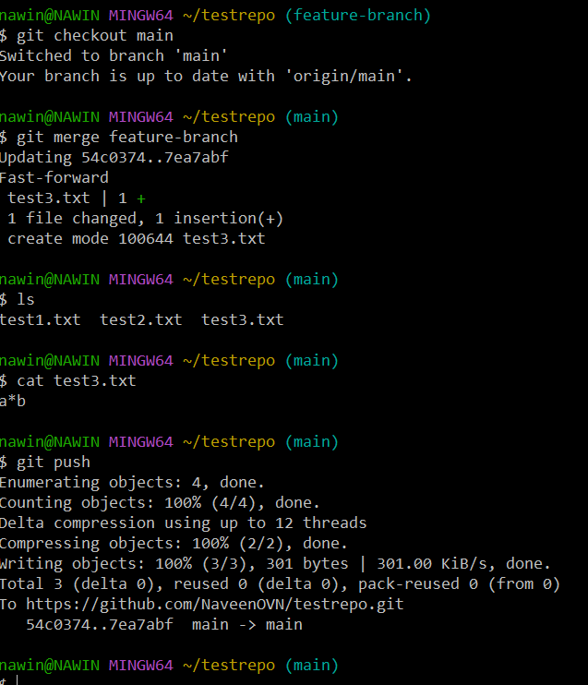

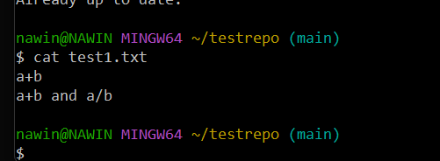
REBASH

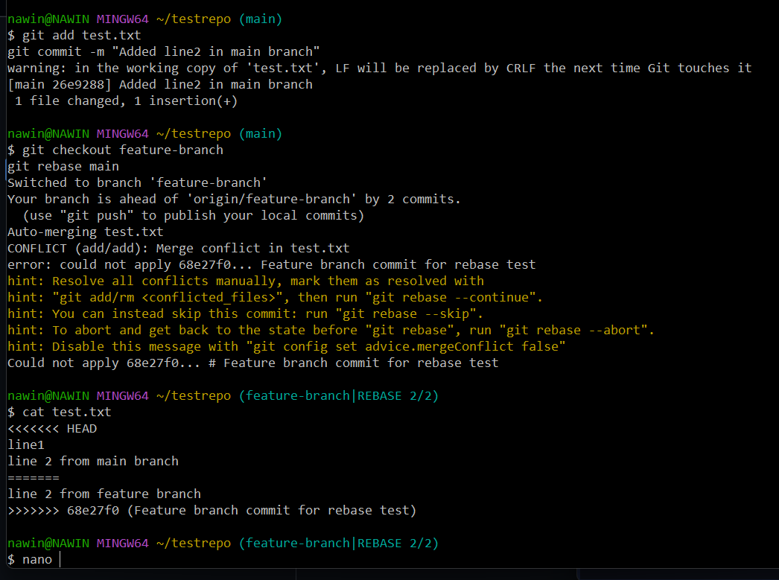

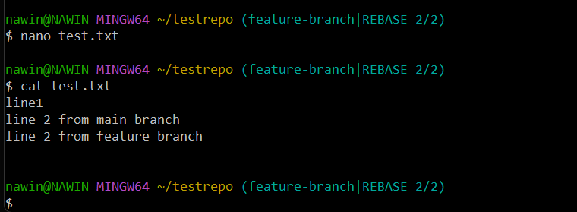
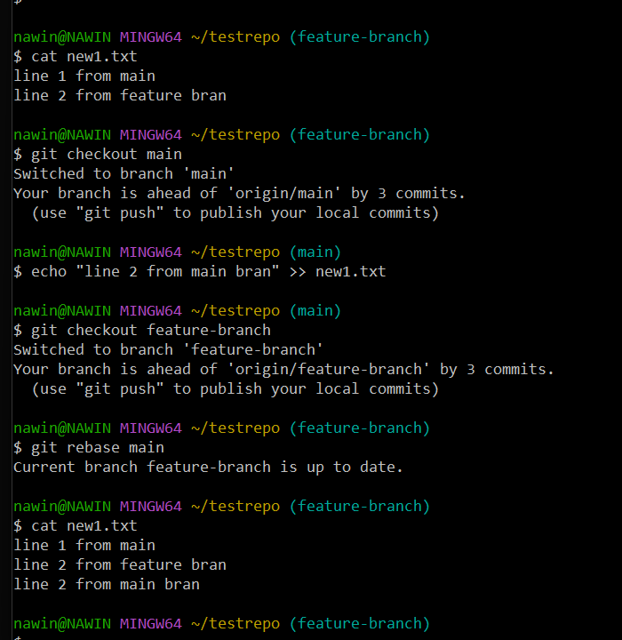

STASH

Temporary save in Feature branch
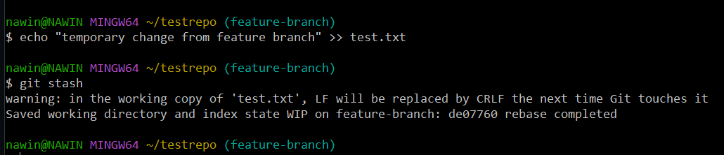

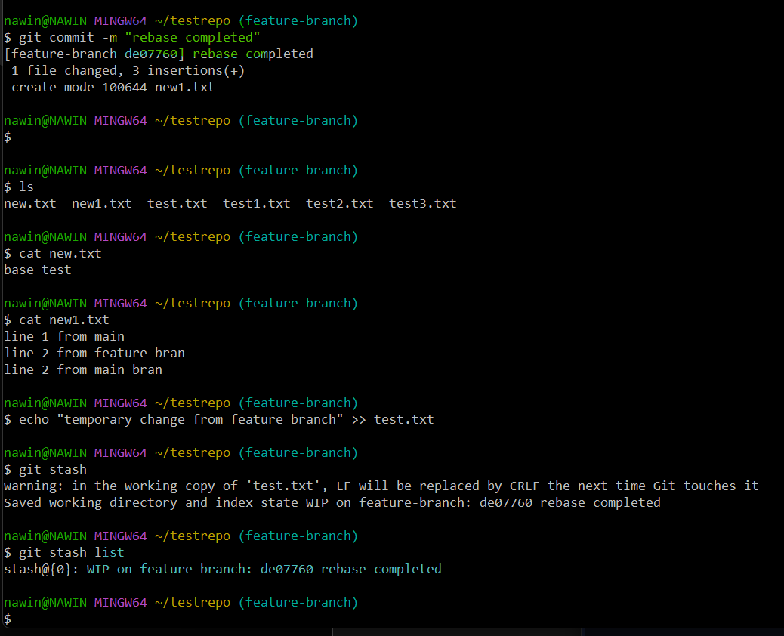

PUSHED THE COMMITS FROM FEATURE BRANCH TO REMOTE
